**PART 1**

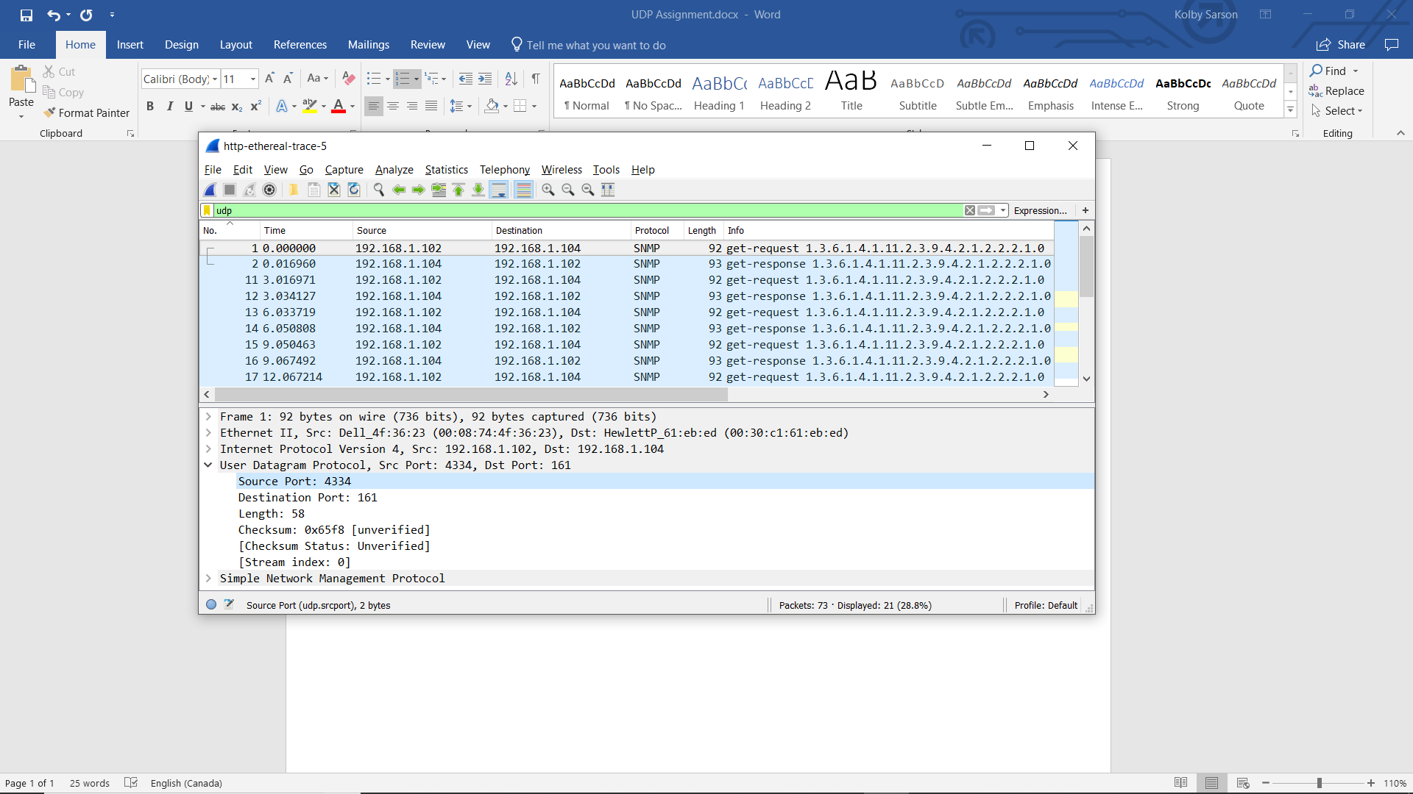

1. There are 4 fields in the header, which are Source Port, Destination port, Length and Checksum.
2. Each field is 2 bytes.
3. The value in the Length field is the length of the 4 header fields summed, plus 42 encapuslated data bytes, totalling 50 bytes.
4. The maximum number of bytes that can be included in a UDP payload is 216-1-(# header bytes). 216-1-8 = 65536-9 = 65527 bytes.
5. The largest possible Source Port number is 216-1=65535.
6. The protocol number for UDP is 17, which is 11 in hex.



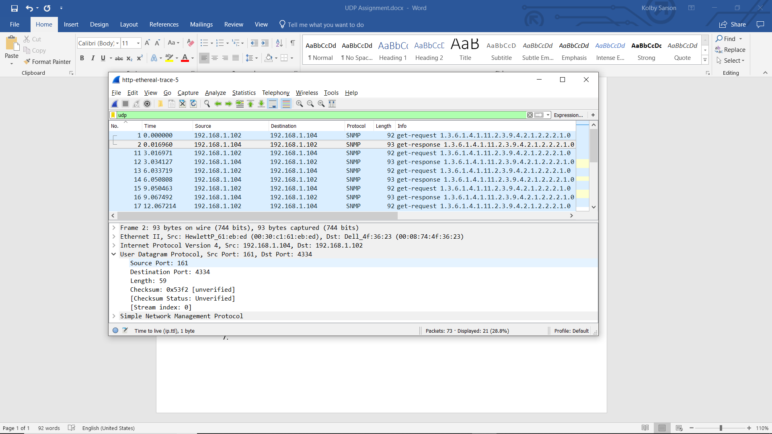

1. Between the get-request and get-response UDPs, the Destination Port of one is the Source Port of the other. (RequestDestPort=ResponseSourcePort & ReuestSourcePort=ResponseDestPort).